Project report on
HYBRID CONTROLLER COMPUTER INTERFACE
Submitted by:
Vikas Singh
Parag Rajhans
Aditya Athalye
Akshay Baviskar
Viraj Deshmukh

Project Guide:
Department: Computer Engineering
Year:2010-2011
Head Of Department:Mrs. S. K. Shukla

V.P.M’s Polytechnic, Thane
Acknowledgement

It is indeed a matter of pleasure and proud privilege to be able to present this project on “Hybrid Controller Computer Interface”. The completion of project work is a milestone in students life and its execution is inevitable in the hands of the guide. We are highly indebted the Project Guide “Mrs. ” for her invaluable guidance and appreciation for giving form and substance to this report, for guiding and correcting various documents of us with attention and care. It is due to her enduring efforts, patience and enthusiasm which has given a sense of direction and purposefulness to this project and ultimately made it to success.

We take immense pleasure in thanking H.O.D “Mrs. S.K.Shukla” for having permitted us to carry out this project and for her co-operation.
We would like to express our deep regards and gratitude to the Principal “Professor D.K.Nayak.”

Words are inadequate in offering our thanks to the staff members for their encouragement and co-operation in carrying out the project work.

Our thanks and appreciation also goes to our colleagues in developing the project and people who willingly helped us with their abilities.

Finally, yet importantly, we would like to express our heartfelt thanks to our beloved parents for their blessings, our friends/classmates for their help and wishes for the successful completion of this project. Really it is highly impossible to repay the debt of all the people who have directly or indirectly helped us performing the project.

INDEX
Title | Page Number
Introduction | 4
Hardware | 7
Concepts and Implementation | 16
Softwares | 34
Coding And Forms | 45
Applications | 69
Future Scope | 70
References | 71

Introduction

- Virtually all home computers today use traditional interfacing i.e., with keyboard and mouse.
- New home pc’s are also being developed and introduced which include touch screens and voice support which increases the level of interactivity but increases the cost significantly.
- Wouldn’t it be cool if you could just point at screen, wave your hands, make gestures, give voice commands and watch your actions controlling your pc or workstation and that too which is cost effective? Definitely it would be super cool.
- Our Project Aims Exactly at this…It Aims at Creating a Hybrid Computer Interface at Low Cost

Hybrid Means “Mix”
- So in our context Hybrid Controllers for pc means using a mixture of controllers (apart from the traditional Mouse and Keyboard) to Interact with the computer
- It is not only limited to computers but to any interface which is configurable

What Controller ?
- To form the hybrid interface…a number for devices, softwares are used which are made from ground up or readymade
- In our Project we will be using the controller of a popular gaming console Nintendo Wii—the contoller– WiiRemote (wiimote) and Nunchuk
- All communication between wiimote and pc will be done via Bluetooth
- Programmer Software : GlovePIE
Why Wiimote ??
- Our Project Deals with controlling the computer by implementing the concepts of Hand Motion movements, Universal Touch screens, Finger Tracking, Gesture Tracking
- All the Above Concepts are Inbuilt into the Wiimote and the Nunchuk
- That means…my Wiimote And Nunchuk can sense my movements, Motion Gestures and many more..
- So Using Capabilities of Wiimote And Nunchuk (IR Tracking, Motion Capture, Gesture recognition and Buttons!!) we can control the pc
- Example: If My Wiimote and Nunchuk are swung upwards.. can write a program to detect upwards motion and perform a window close operation on my pc
- Similarly we can write a program to track an infrared source of light (by wiimote’s inbuilt infrared camera tracking by spatial triangulation) to control a mouse on screen.
- Thus my combining such programs we can create a virtual interface in which we just move our hands, make motion gestures, touch the screen or speak to interface with the computer.
- The Programmer used to do all this is GlovePIE .

Hardware

1.Wiimote
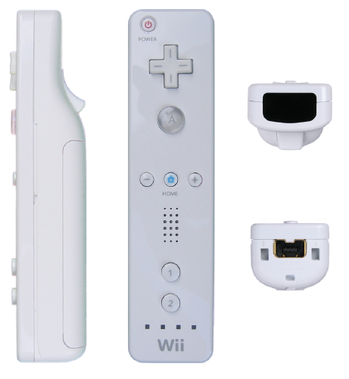
A main feature of the Wii Remote is its motion sensing capability, which allows the user to interact with and manipulate items on screen via gesture recognition and pointing through the use of accelerometer and optical sensor(IR Tracking).

- It also includes 12 digital buttons
- The Wii Remote ,sometimes unofficially nicknamed "Wiimote", is the primary controller for Nintendo's Wii console.
- A main feature of the Wii Remote is its motion sensing capability, which allows the user to interact with and manipulate items on screen via gesture recognition and pointing through the use of accelerometer and optical sensor technology.
- Another feature is its expandability through the use of attachments. The attachment bundled with the Wii console is the Nunchuk, which complements the Wii Remote by providing functions similar to those in gamepad controllers.
- Some other attachments include the Wii Classic Controller, Wii Zapper, and the Wii Wheel, originally used for Mario Kart.
- The controller was revealed at the Tokyo Game Show on October 14, 2005, with the name "Wii Remote" announced April 27, 2006. It has since received much attention due to its unique features and the contrast between it and typical gaming controllers. It has also gained significant attention from hackers using it to control non Wii-related devices through Wii homebrew.
- It was only a matter of time. Because Nintendo chose to use the Bluetooth standard for its Wii remote, enterprising developers have already discovered ways to use it on PCs. Early Windows, Mac, and Linux drivers are available that let your Wiimote act as a mouse (for gaming, presentations, etc.), or to control a PC game. Other uses are more imaginative, for example here's a video of someone using the Wiimote to compose music or sound effects.

- The Wiimote is quite a sophisticated device internally. According to Wikipedia and manufacturer information it contains an ADI ADXL330 3-axis iMEMS accelerometer:
- The ADXL330 is used to sense motion of the game player in three dimensions of freedom: forward-backward, left-right, and up-down. When the new controller is picked up and manipulated, it provides a quick element of interaction, sensing motion, depth and positioning dictated by the acceleration of the controller itself.
- If that weren't enough, the front of the Wiimote houses a tiny one-megapixel camera that constantly looks for the ten tiny IR lights in the Wii's sensor bar, and uses those to figure out exactly where you're pointing the remote. Unlike traditional light guns (which rely on special patterns on the display), this point could be on the screen or off. Feedback in the form of a rumble motor and a tiny speaker can make the immersion even more complete. More technical info can be found here.
- Imagine the possibilities such a rich controller can offer beyond gaming, such as remote robotic manipulation, 3d sculpting, database exploration, and more. Thanks to a standard wireless protocol, commodity pricing, and open source drivers, the technology in the Wiimote may herald a turning point in human-machine interfaces.

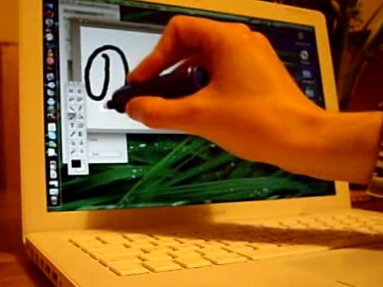
Johnny Lee's WiiMote Whiteboard software used for light pen-type computer input

Development
Development of a motion enabled controller began in 2001, coinciding with development of the Wii console. In that year, Nintendo licensed a number of motion-sensing patents from Gyration Inc., a company that produces wireless motion-sensing computer mice. Nintendo then commissioned Gyration Inc. to create a one-handed controller for it, which eventually developed the "Gyropod", a more traditional gamepad which allowed its right half to break away for motion-control. At this point, Gyration Inc. brought in a separate design firm Bridge Design to help pitch its concept to Nintendo. Under requirement to "roughly preserve the existing Game Cube button layout", it experimented with different forms "through sketches, models and interviewing various hardcore gamers". By "late 2004, early 2005", however, Nintendo had come up with the Wii Remote's less traditional "wand shape", and the design of the Nunchuk attachment. Nintendo had also decided upon using a motion sensor, infrared pointer, and the layout of the buttons, and by the end of 2005 the controller was ready for mass production.
During development of the Wii Remote, video game designer Shigeru Miyamoto brought in mobile phones and controllers for automotive navigation systems for inspiration, eventually producing a prototype that resembled a cell phone. Another design featured both an analog stick and a touchscreen, but Nintendo rejected the idea of a touchscreen on the controller, "since the portable console and living-room console would have been exactly the same".
Sources also indicate that the Wii Remote was originally in development as a controller for the Nintendo GameCube, rather than the Wii. Video game developer Factor 5 stated that during development of launch title Star Wars Rogue Squadron II: Rogue Leader, it had an early prototype of a motion-sensing controller. Video game journalist Matt Casamassina, from gaming website IGN, stated that he believed that Nintendo had planned to release the Wii Remote for the GameCube, noting that "Nintendo said that it hoped that GCN could enjoy a longer life cycle with the addition of top-secret peripherals that would forever enhance the gameplay experience."^{[6]} He suggested that Nintendo may have wanted to release the Wii Remote with a new system, instead of onto the GameCube, as "[the] Revolution addresses one of the GameCube's biggest drawbacks, which is that it was/is perceived as a toy."^{[6]}

Third-party use
- Since the release of the Wii console, people have been exploring different new ways in which to use the Wii Remote. Many third-party applications are currently in development through Wii homebrew. One popular Windows program called GlovePIE allows the Wii Remote to be used on a personal computer to emulate a keyboard, mouse or joystick.]
- Connecting the Wii Remote to a personal computer is done via a Bluetooth connection. The Bluetooth program BlueSoleil has been proven to successfully connect a Wii Remote to a PC. Still another program (like GlovePIE) is needed to utilize the Wii Remote's protocol and to use the data it offers.
- Connecting the Wii Remote to a personal computer is done via a Bluetooth connection. The Bluetooth program BlueSoleil has been proven to successfully connect a Wii Remote to a PC. Still another program (like GlovePIE) is needed to utilize the Wii Remote's protocol and to use the data it offers.
- The Wii Remote Bluetooth protocol can be implemented on other devices including cell phones, which often have poor usability with games. Two students have demonstrated this concept by creating a driver software that has the capability to connect the Wii Remote to a Symbian OS smartphone. The idea behind this driver is that a mobile phone with a TV-out port can replace the game console.
- Programmer Johnny Lee has posted video demos and sample code at his website related to the use of the Wii Remote for finger tracking, low-cost multipoint interactive whiteboards, and head tracking for desktop VR displays. This was the subject for his presentation at the prestigious TED conference, where he demonstrated several such applications.
- The Wii mote Project forum has become the discussion, support and sharing site for Lee's Wii Remote projects and other newer developments.
Studies have also been conducted to use the Wii Remote as a practice method to fine-tune surgeons' hand motions. Utilizing Darwiin Remote, researchers at the University of Memphis have adapted the Wii Remote for data collection in cognitive psychology experiments.

Design
The Wii Remote assumes a one-handed remote control-based design instead of the traditional gamepad controllers of previous gaming consoles. This was done to make motion sensitivity more intuitive, as a remote design is fitted perfectly for pointing, and in part to help the console appeal to a broader audience that includes non-gamers. The body of the Wii Remote measures 148 mm (5.83 in) long, 36.2 mm (1.43 in) wide, and 30.8 mm (1.21 in) thick. The Wii Remote model number is RVL-003, a reference to the project codename "Revolution". The controller communicates wirelessly with the console via short-range Bluetooth radio, with which it is possible to operate up to four controllers as far as 10 meters (approx. 30 ft) away from the console. However, to utilize pointer functionality, the Wii Remote must be used within five meters (approx. 16 ft) of the Sensor Bar. The controller's symmetrical design allows it to be used in either hand. The Wii Remote can also be turned horizontally and used like a Famicom/NES controller, or in some cases (like Excite Truck, Sonic and the Secret Rings, Mario Kart Wii, and Sonic and Sega All-Stars Racing) a steering wheel. It is also possible to play a single-player game with a Wii Remote in each hand, as in the Shooting Range game contained in Wii Play.
At E3 2006, a few minor changes were made to the controller from the design presented at the Game Developer's Conference. The controller was made slightly longer, and a speaker was added to the face beneath the center row of buttons. The "B" button became more curved resembling a trigger. The "Start" and "Select" buttons were changed to plus "+" and minus "–", and the "b" and "a" buttons were changed to 1 and 2 to differentiate them from the "A" and "B" buttons. Also, the symbol on the "Home" button was changed from a blue dot to a shape resembling a home/house, the shape of the power button was made circular rather than rectangular, and the blue LEDs indicating player number are now labeled using small Braille-like raised dots instead of Arabic numerals, with "1" being "•", "2" being "••", "3" being "•••", and "4" being "••••". The Nintendo logo at the bottom of the controller face was replaced with the Wii logo. Also, the expansion port was redesigned, with expansion plugs featuring a smaller snap-on design.
The blue LEDs also show how much battery power remains on the Wii Remote. By pressing any button, besides the power button while the controller is not being used to play games, a certain number of the four blue LEDs will light up, showing the battery life: four of the LEDs flash when it is at, or near, full power. Three lights flash when it is at 75%, two lights when at 50%, and one light flashes when there is 25% or less power remaining.
Similarities have been noted between the Wii Remote and an early Dreamcast controller prototype.
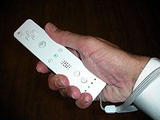
Demo Wii Remote shown at a Nintendo event at the Hotel Puerta America.In the Red Steel trailer shown at E3 2006, the Wii Remote featured a smaller circular shaped image sensor, as opposed to the larger opaque IR filters shown on other versions. In the initial teaser video that revealed the controller at Tokyo Game Show 2005, the 1 and 2 buttons were labeled X and Y, respectively

2.Bluetooth Dongle
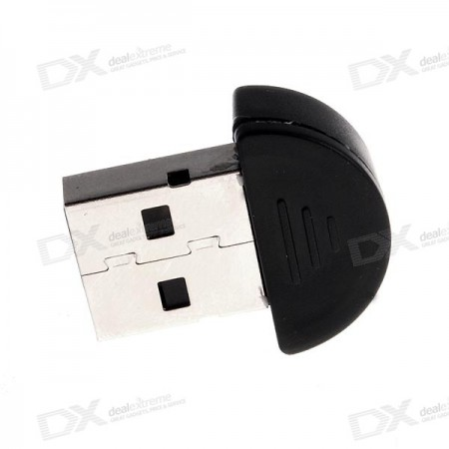
Bluetooth is a proprietary openwireless technology standard for exchanging data over short distances (using short wavelength radio transmissions) from fixed and mobile devices, creating personal area networks (PANs) with high levels of security. Created by telecoms vendor Ericsson in 1994, it was originally conceived as a wireless alternative to RS-232 data cables. It can connect several devices, overcoming problems of synchronization.
Bluetooth is managed by the Bluetooth Special Interest Group, which has more than 14,000 member companies in the areas of telecommunication, computing, networking, and consumer electronics. The SIG oversees the development of the specification, manages the qualification program, and protects the trademarks. To be marketed as a Bluetooth device, it must bequalified to standards defined by the SIG. A network of patents are required to implement the technology and are only licensed to those qualifying devices; thus the protocol, whilst open, may be regarded as proprietary.

Bluetooth v2.0 + EDR
This version of the Bluetooth Core Specification was released in 2004 and is backward compatible with the previous version 1.2. The main difference is the introduction of an Enhanced Data Rate (EDR) for faster data transfer. The nominal rate of EDR is about 3 Mbit/s, although the practical data transfer rate is 2.1 Mbit/s. EDR uses a combination of GFSK and Phase Shift Keying modulation (PSK) with two variants, π/4-DQPSK and 8DPSK. EDR can provide a lower power consumption through a reduced duty cycle.
The specification is published as "Bluetooth v2.0 + EDR" which implies that EDR is an optional feature. Aside from EDR, there are other minor improvements to the 2.0 specification, and products may claim compliance to "Bluetooth v2.0" without supporting the higher data rate. At least one commercial device states "Bluetooth v2.0 without EDR" on its data sheet.
[edit]Bluetooth v2.1 + EDR
Bluetooth Core Specification Version 2.1 + EDR is fully backward compatible with 1.2, and was adopted by the Bluetooth SIG on July 26, 2007.[36]
The headline feature of 2.1 is secure simple pairing (SSP): this improves the pairing experience for Bluetooth devices, while increasing the use and strength of security. See the section onPairing below for more details.[38]
2.1 allows various other improvements, including "Extended inquiry response" (EIR), which provides more information during the inquiry procedure to allow better filtering of devices before connection; sniff subrating, which reduces the power consumption in low-power mode
Bluetooth v3.0 + HS
Version 3.0 + HS of the Bluetooth Core Specification was adopted by the Bluetooth SIGon April 21, 2009. Bluetooth 3.0+HS supports theoretical data transfer speeds of up to 24 Mbit/s, though not over the Bluetooth link itself. Instead, the Bluetooth link is used for negotiation and establishment, and the high data rate traffic is carried over a colocated 802.11 link. Its main new feature is AMP (Alternate MAC/PHY), the addition of 802.11 as a high speed transport. Two technologies had been anticipated for AMP: 802.11 and UWB, but UWB is missing from the specification.
The High-Speed part of the specification is not mandatory, and hence only devices sporting the "+HS" will actually support the Bluetooth over Wifi high-speed data transfer. A Bluetooth 3.0 device without the HS suffix will not support High Speed, and needs to only support Unicast Connectionless Data (UCD), as shown in the Bluetooth 3.0+HS specification, Vol0, section 4.1 Specification Naming Conventions.

Concepts and Implementation

1.Motion Awesomeness
Referring to the image..we can track the wiimote’s inclinations in three axis x, y, z
- Each Axis is tracked from a point range of -10 to +10 with a precision of two floats i.e., from -10.00 to +10.00
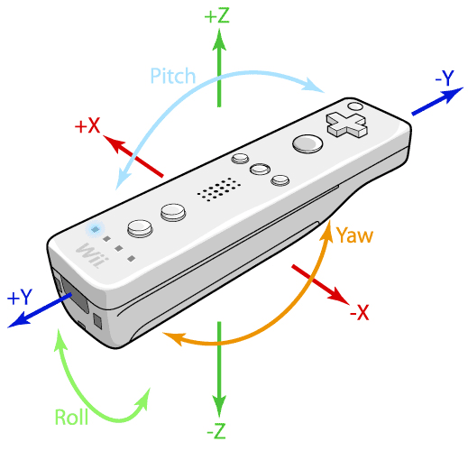

Through the GlovePIE Programmer, we can also track the wiimote’s and nunchuk’s relative motion i.e., not just the inclination but also the swing actions (relative motion).
Thus, if we map the direction keys and other keys on the wiimote to arrow keys, enter key of keyboard and also map the swing right ,swing left and swing up motions, we can navigate in a window by swinging wiimote or nunchuk left, right to go to next or previous directory, swing up to close a file, press a button(mapped to enter key) to open a file
- Also, by tracking the inclination in real time, we can create controls for many games such as flight simulator where, if ,holding the wiimote vertically, we tilt the wiimote forward, (i.e. by increasing the y-axis inclination of wiimote), we can make the plane dive or in contrast make it leap
- It is like we are actually controlling the flight by tilting the wiimote as if it is the plane’s joystick
- Various other orientation differences can be mapped to simulate driving a car, or a bike
Sensing
The Wii Remote has the ability to sense acceleration along three axes through the use of an ADXL330 accelerometer. The Wii Remote also features a PixArt optical sensor, allowing it to determine where the Wii Remote is pointing.
Unlike a light gun that senses light from a television screen, the Wii Remote senses light from the console's Sensor Bar (model number RVL-014), which allows consistent usage regardless of a television's type or size. The Sensor Bar is about 20 cm (8 in) long and features ten infrared LEDs, five at each end of the bar The LEDs furthest from the center are pointed slightly outwards, the LEDs closest to the center are pointed slightly inwards, while the rest are pointed straight forward. The Sensor Bar's cable is 353 cm (11 ft 7 in) in length. The bar may be placed above or below the television, and should be centered. If placed above, the sensor should be in line with the front of the television, and if placed below, should be in line with the front of the surface the television is placed on. It is not necessary to point directly at the Sensor Bar, but pointing significantly away from the bar will disrupt position-sensing ability due to the limited viewing angle of the Wii Remote.
Use of the Sensor Bar allows the Wii Remote to be used as an accurate pointing device up to 5 meters (approx. 16 ft) away from the bar. The Wii Remote's image sensor is used to locate the Sensor Bar's points of light in the Wii Remote's field of view. The light emitted from each end of the Sensor Bar is focused onto the image sensor which sees the light as two bright dots separated by a distance "mi" on the image sensor. The second distance "m" between the two clusters of light emitters in the Sensor Bar is a fixed distance. From these two distances m and mi, the Wii CPU calculates the distance between the Wii Remote and the Sensor Bar using triangulation. In addition, rotation of the Wii Remote with respect to the ground can also be calculated from the relative angle of the two dots of light on the image sensor. Games can be programmed to sense whether the image sensor is covered, which is demonstrated in a Microgame of Smooth Moves, where if the player does not uncover the sensor, the champagne bottle that the remote represents will not open.
The Sensor Bar is required when the Wii Remote is controlling up-down, left-right motion of a cursor or reticle on the TV screen to point to menu options or objects such as enemies in first-person shooters. Because the Sensor Bar also allows the Wii Remote to calculate the distance between the Wii Remote and the Sensor Bar, the Wii Remote can also control slow forward-backward motion of an object in a 3-dimensional game. Rapid forward-backward motion, such as punching in a boxing game, is controlled by the acceleration sensors. Using these acceleration sensors (acting as tilt sensors), the Wii Remote can also control rotation of a cursor or other objects.
The use of an infrared sensor to detect position can cause some detection problems when other infrared sources are around, such as incandescent light bulbs or candles. This can be easily alleviated by using fluorescent lights around the Wii, which emit little to no infrared light. Innovative users have used other sources of IR light as Sensor Bar substitutes such as a pair of flashlights and a pair of candles. Such substitutes for the Sensor Bar illustrate the fact that a pair of non-moving lights provide continuous calibration of the direction that the Wii Remote is pointing and its physical location relative to the light sources. There is no way to calibrate the position of the cursor relative to where the user is pointing the controller without the two stable reference sources of light provided by the Sensor Bar or substitutes. Third-party wireless sensor bars have also been released.
The position and motion tracking of the Wii Remote allows the player to mimic actual game actions, such as swinging a sword or aiming a gun, instead of simply pressing buttons. An early marketing video showed actors miming actions such as fishing, cooking, drumming, conducting a musical ensemble, shooting a gun, sword fighting, and performing dental surgery.
The LEDs can be seen through some cameras and other devices with a wider visible spectrum than the human eye, such as most digital cameras and camera phones.
The Wii Remote also has twelve buttons. It has a power button to toggle the Wii on and off, a d-pad which is interpreted as four separate buttons, and buttons labeled "A", "B", "1", "2", "home", "-", and "+".

Memory
The Wii Remote contains a 16 KiB EEPROM chip from which a section of 6 kilobytes can be freely read and written by the host. Part of this memory is available to store up to ten Mii avatars, which can be transported to use with another Wii console. At least 4,000 bytes are available and unused before the Mii data. Pokémon Battle Revolution and Super Swing Golf also use this memory. This function is also used in Super Smash Bros. Brawl, allowing the user to save controller configuration data to the Wii Remote. Monster Hunter Tri also uses this function by allowing players to save their profiles to the Wii Remote.

Power source
The Wii Remote uses two AA batteries as a power source, which can power a Wii Remote for 60 hours using only the accelerometer functionality and 25 hours using both accelerometer and pointer functionality. An official direct recharging option for the Wii Remote does not exist, but various third-party manufacturers market charging solutions for the controller (see Third-party accessories for the Wii RemoteChargers). According to an interview with Nintendo industrial designer Lance Barr, limitations of the Wii Remote's expansion port make it unlikely that it will be used for internal battery charging. Although Nintendo discourages other rechargeable battery types such as lithium ion (Li-ion) and nickel-cadmium (NiCd), the company's support website indicates that nickel-metal hydride (NiMH) rechargeable batteries may be used. A 3300µF capacitor provides a temporary source of power during quick movements of the Wii Remote when connection to the batteries may be temporarily interrupted.
2.IR Tracking :
- IR Tracking is the Tracking of movement of an IR light Source Used To Communicate with the PC.
- This Is Done By The Wiimote IR Camera.
- By Using IR Tracking and By Implementing Various Codes, We Can Control Computer By Our FINGERS(Finger Tracking) And Also Turn Any Display into TOUCHSCREENS!!!!!!!!!
- Infra red technology is so useful because of it’s ability to capture light and height that the eye cannot see. This is why they are valuable as surveillance equipment. Within a limited range, and IR camera can capture all of the motion and activity in any given area, allowing you to see things that the naked eye just can’t.
They can detect heat as well as light signatures, so hiding practically isn’t an option, giving you the edge when you’re trying to locate someone or spot an intruder.

2.1.Finger Tracking
- What Basically We will Be doing is track our fingers and move them around in open space to control the mouse on screen and perform other functions.
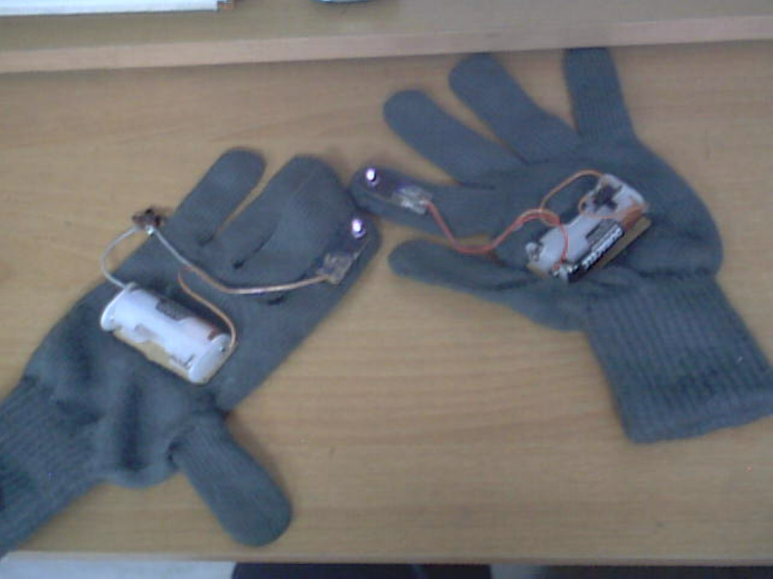
- How this is Actually done is: the user would wear 2sets of gloves which would have IR-LEDs attached to the Tip of the of the thumb and First Finger on both the gloves
- The Wiimote’s IR Camera Tracks IR Light By 45degree range as given in the picture where the Blue Line Indicates Effective IR Tracking Range Of the Camera.
- The wiimote will be placed above the computer screen in front of the user from where the camera can see the IR LED on the user’s glove
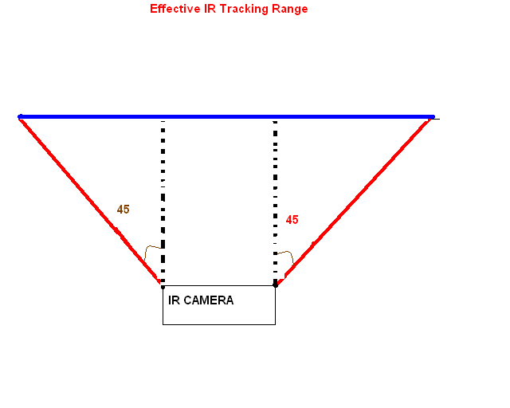
Once Placed, the camera Can Track the position of the IR LED in a total resolution of 1024x768 irrespective of the LED’s distance from the camera.
- Thus the Exact Co-ordinates of the IR LED is Determined by Spatial Triangulation and after the co-ordinates in real Coordinate System is determined, it is translated into cursor co-ordinates by the Resolution set on the monitor.
- So, As the Finger is moved in air, the cursor on screen in moved.
- The Wiimote can track up to 4 IR Sources so we can write programs to perform various functions by tracking 4 IR LED fitted gloves i.e. 2 on each glove.
- Example, 1 Led Will control the movement of cursor, and if the second led is detected, the program will perform double Click and so on..

In the field of technology and image processing, finger tracking is a high-resolution technique that is employed to know the consecutive position of the fingers of the user and hence represent objects in 3D. In addition to that, the finger tracking technique is used as a tool of the computer, acting as an external device in our computer, similar to a keyboard and a mouse.

In the field of technology and image processing, finger tracking is a high-resolution technique that is employed to know the consecutive position of the fingers of the user and hence represent objects in 3D. In addition to that, the finger tracking technique is used as a tool of the computer, acting as an external device in our computer, similar to a keyboard and a mouse. A good example can be seen here
The finger tracking system is focused on user-data interaction, where the user interacts with virtual data, by handling through the fingers the volumetric of a 3D object that we want to represent. This system was born based on the human-computer interaction problem. The objective is to allow the communication between them and the use of gestures and hand movements to be more intuitive, Finger tracking systems have been created. These systems track in real time the position in 3D and 2D of the orientation of the fingers of each marker and use the intuitive hand movements and gestures to interact.

Types of tracking
There are many options for the implementation of finger tracking. A great number of theses have been done in this field in order to make a global partition as an objective. We could divide this technique into finger tracking and interface. Regarding the last one, it computes a sequence estimation of the image which detects the hand part of the background. Regarding the first one, to carry out this tracking, we need an intermediate external device, used as a tool for executing different instructions.

Tracking with interface
In this system we use motion capture; a tracking of the location of the markers and patterns in 3D is performed, the system identifies them and labels each marker according to the position of the user’s fingers. The coordinates in 3D of the labels of these markers are produced in real time with other applications.

Markers
Some of the optical systems, like Vicon, are able to capture hand motion through markers. In each hand we have a marker per each “operative” finger. Three high-resolution cameras are responsible for capturing each marker and measure its positions. This will be only produced when the camera is able to see them. The visual markers, usually known as rings or bracelets, are used to recognize user gesture in 3D. In addition, as the classification indicates, these rings act as an interface in 2D.

Occlusion as an interaction method
The visual occlusion is a very intuitive method to provide a more realistic viewpoint of the virtual information in three dimensions. The interfaces provide more natural 3D interaction techniques over base 6.

Marker functionality
Markers operate through interaction points, which are usually already set and we have the knowledge about the regions. Because of that, it is not necessary to follow each marker all the time; the multipointers can be treated in the same way when there is only one operating pointer. To detect such pointers through an interaction, we enable ultrasound infrared sensors. The fact that many pointers can be handled as one, problems would be solved. In the case when we are exposed to operate under difficult conditions like bad illumination, motion blurs, malformation of the marker or occlusion. The system allows following the object, even though if some markers are not visible. Because of the spatial relationships of all the markers are known, the positions of the markers that are not visible can be computed by using the markers that are known. There are several methods for marker detection like border marker and estimated marker methods.
- The Homer technique includes ray selection with direct handling: An object is selected and then its position and orientation are handled like if it was connected directly to the hand.
- The Conner technique presents a set of 3D widgets that permit an indirect interaction with the virtual objects through a virtual widget that acts as an intermediary.

Application
Definitely, the finger tracking systems are use to represent a virtual reality. However its application has gone to professional level 3D modeling, companies and projects directly in this case overturned. Thus such systems rarely have been used in consumer applications due to its high price and complexity. In any case, the main objective is to facilitate the task of executing commands to the computer via natural language or interacting gesture.
The objective is centered on the following idea computers should be easier in terms of usage if there is a possibility to operate through natural language or gesture interaction. The main application of this technique is to highlight the 3D design and animation, where software like Maya and 3D StudioMax employ these kinds of tools. The reason is that is that allow a more accurate and simple control of the instructions that we want to execute. This technology offers many possibilities, where the sculpture, building and modeling in 3D in real time through the use of a computer is the most important.
Finger tracking techniques
One method used to segment the moving hand from the background image as a whole is subtraction of one image from its successor. Stationary background objects such as paper documents, projected workspaces, pens andso on are ignored and only the moving hand is isolated. Further image processing can determine the fingertip’s position. Problems can arise if other objects move or if there are gaps along the lines of motion. The biggest problem in Wellner’s systems was in the speed,as subtraction and subsequent processing was just too slow.

A better method is to use template matching. Objectsin the scene are compared to a known fingertip template.Once the fingertip is located, the tracking problembecomes: “Given an observation of an object at time t,determine the most likely position of that same object at time t+DT”. In order to perform tracking fast enough thesearch space is reduced to a radius from the currentposition. The higher the speed, the larger the search areaand the more expensive the template matching. Thepractical result was that movement in accordance with
Fitts’ Law could not be followed quickly enough.Moreover even though the template can be altered toallow for finger rotation, it is easy to break tracking if thetemplate locks onto a background object. A furtherdisadvantage of templates is that the important fingertip
edge is only a small part of the whole area, resulting inunwelcome processing overhead.

Other ubiquitous computing environments are tryingto provide practical interaction by interpreting naturalmovements as commands. Thus it is natural to point tosomething to indicate it to someone, it is natural toperform an action with something by grabbing it and
moving it about. For instance Rauterberg et al trackthe movement of wooden blocks by image processing.Another possibility is to draw letters on a whiteboard for interpretation as commands, as in the Bright Board system

The Problem of Tracking

Apart from the definition of tracking above, another much more general view is that it entails “examining a sequence of images to locate a target and predict its position throughout the sequence”. This approach is not entirely applicable to the Digital Desk. Although we
could look back through the sequence of images, it is an expensive operation, requiring time to process and space for storage, as well as constant updating. Nevertheless it does suggest the use of a Kalman filter — a commonly used statistical approach to optimize a variable like position using measurements, predictions and errors. Blake et al combined Kalman filtering with visual contours or ‘snakes’ to produce Kalman Snakes, which were applied to track a human hand in motion. Despite contortions and rotations, the tracker can maintain a constant elastic band line around the hand and can resist sudden changes in movement or position due to the hand passing over a cluttered background. Only a few pixels need to be searched on either side of the estimated contour, but computation of the snakes is complicated. As yet these techniques are too slow for the Digital Desk. The above algorithms reduce to either estimation or moving a search space. Our algorithm employs a combination of these two approaches.

2.2Touch screen
- This Is Also Implemented By IR Tracking.
- It is Similar to Finger Tracking in concept and design but different in working.
- The IR LED is Placed on the Nail-side of the give and is not constantly on.
- This Depends on Tracking of the IR LED respective of the Distance from the camera i.e., the tracking values will change if the distance between camera and IRLED is changed.
- Thus the Wiimote is Placed Behind the user from where it can see the monitor in a 45degree view.
- The Tip of the first finger of the glove has a pressure switch which switches on the IR LED only if the user touches the screen with his finger.
- So, First the 4point Touch Calibration is done.
- What it is actually is, it maps the distance of the monitor from the camera and converts the monitor co-ordinates to camera co-ordinates .
- The user is provided with 4 points on screen where he must touch, this provides the co-ordinates of where the user has touched and then translates it into monitor resolution co-ordinates.
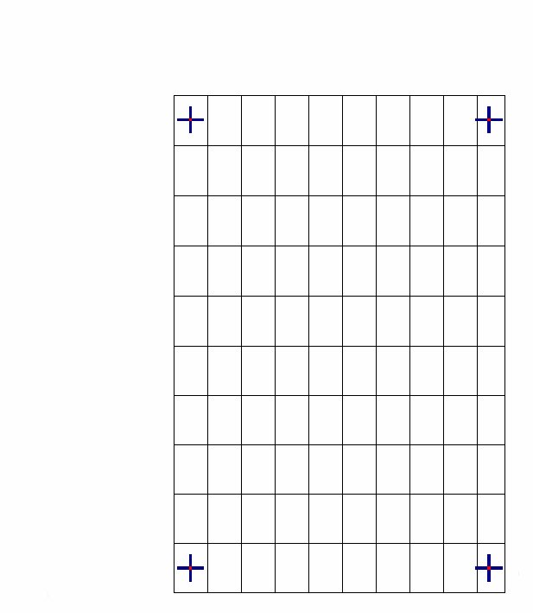
- Once This Is done, the user then just have to touch the monitor on various icons buttons etc.
- When the user touches the screen, pressure switch enables the IR LED and this is registered by the wiimote and is interpreted by our program as a single click.
- So now, the user just have to touch, drag ,tap, double tap and control the computer via touch as if it was a real touch screen.

- That means simply double tap on an icon, and the application will open
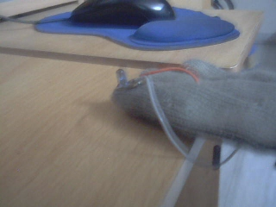

Simply touch and drag the scrollbar up and down and scrolling will be done.
- Simply Touch and Drag in paint, and start drawing by directly scribbling on the screen

A touchscreen is an electronic visual display that can detect the presence and location of a touch within the display area. The term generally refers to touching the display of the device with a finger or hand. Touchscreens can also sense other passive objects, such as a stylus. Touchscreen is common in devices such as all-in-one computers, tablet computers, and smartphones.
The touchscreen has two main attributes. First, it enables one to interact directly with what is displayed, rather than indirectly with a cursor controlled by a mouse or touchpad. Secondly, it lets one do so without requiring any intermediate device that would need to be held in the hand. Such displays can be attached to computers, or to networks as terminals. They also play a prominent role in the design of digital appliances such as the personal digital assistant (PDA), satellite navigation devices, mobile phones, and video games.

Resistive
Main article: Resistive touchscreen
A resistive touchscreen panel is composed of several layers, the most important of which are two thin, electrically conductive layers separated by a narrow gap. When an object, such as a finger, presses down on a point on the panel's outer surface the two metallic layers become connected at that point: the panel then behaves as a pair of voltage dividers with connected outputs. This causes a change in the electrical current, which is registered as a touch event and sent to the controller for processing.

Capacitive
A capacitive touchscreen panel is one which consists of an insulator such as glass, coated with a transparent conductor such as indium tin oxide (ITO).^{[7][8]} As the human body is also an electrical conductor, touching the surface of the screen results in a distortion of the screen's electrostatic field, measurable as a change in capacitance. Different technologies may be used to determine the location of the touch. The location is then sent to the controller for processing. Unlike a resistive touchscreen, one cannot use a capacitive touchscreen through most types type of electrically insulating material, such as gloves; one requires a special capacitive stylus, or a special-application glove with finger tips that generate static electricity. This disadvantage especially affects usability in consumer electronics, such as touch tablet PCs and capacitive smartphones.

Infrared

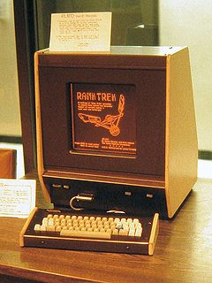
Infrared sensors mounted around the display watch for a user's touchscreen input on this PLATO V terminal in 1981. The monochromatic plasma display's characteristic orange glow is illustrated.
An infrared touchscreen uses an array of X-Y infrared LED and photodetector pairs around the edges of the screen to detect a disruption in the pattern of LED beams. These LED beams cross each other in vertical and horizontal patterns. This helps the sensors pick up the exact location of the touch. A major benefit of such a system is that it can detect essentially any input including a finger, gloved finger, stylus or pen. It is generally used in outdoor applications and point of sale systems which can't rely on a conductor (such as a bare finger) to activate the touchscreen. Unlike capacitive touchscreens, infrared touchscreens do not require any patterning on the glass which increases durability and optical clarity of the overall system.

Dispersive signal technology
Introduced in 2002 by 3M, this system uses sensors to detect the mechanical energy in the glass that occurs due to a touch. Complex algorithms then interpret this information and provide the actual location of the touch.^{[10]} The technology claims to be unaffected by dust and other outside elements, including scratches. Since there is no need for additional elements on screen, it also claims to provide excellent optical clarity. Also, since mechanical vibrations are used to detect a touch event, any object can be used to generate these events, including fingers and stylus. A downside is that after the initial touch the system cannot detect a motionless finger.

Working
Touch-screen monitors have become more and more commonplace as their price has steadily dropped over the past decade. There are three basic systems that are used to recognize a person's touch:
- Resistive
- Capacitive
- Surface acoustic wave
The resistive system consists of a normal glass panel that is covered with a conductive and a resistive metallic layer. These two layers are held apart by spacers, and a scratch-resistant layer is placed on top of the whole setup. An electrical current runs through the two layers while the monitor is operational. When a user touches the screen, the two layers make contact in that exact spot. The change in the electrical field is noted and the coordinates of the point of contact are calculated by the computer. Once the coordinates are known, a special driver translates the touch into something that the operating system can understand, much as a computer mouse driver translates a mouse's movements into a click or a drag.
In the capacitive system, a layer that stores electrical charge is placed on the glass panel of the monitor. When a user touches the monitor with his or her finger, some of the charge is transferred to the user, so the charge on the capacitive layer decreases. This decrease is measured in circuits located at each corner of the monitor. The computer calculates, from the relative differences in charge at each corner, exactly where the touch event took place and then relays that information to the touch-screen driver software. One advantage that the capacitive system has over the resistive system is that it transmits almost 90 percent of the light from the monitor, whereas the resistive system only transmits about 75 percent. This gives the capacitive system a much clearer picture than the resistive system.
On the monitor of a surface acoustic wave system, two transducers (one receiving and one sending) are placed along the x and y axes of the monitor's glass plate. Also placed on the glass are reflectors -- they reflect an electrical signal sent from one transducer to the other. The receiving transducer is able to tell if the wave has been disturbed by a touch event at any instant, and can locate it accordingly. The wave setup has no metallic layers on the screen, allowing for 100-percent light throughput and perfect image clarity. This makes the surface acoustic wave system best for displaying detailed graphics (both other systems have significant degradation in clarity).
Another area in which the systems differ is in which stimuli will register as a touch event. A resistive system registers a touch as long as the two layers make contact, which means that it doesn't matter if you touch it with your finger or a rubber ball. A capacitive system, on the other hand, must have a conductive input, usually your finger, in order to register a touch. The surface acoustic wave system works much like the resistive system, allowing a touch with almost any object -- except hard and small objects like a pen tip.
As far as price, the resistive system is the cheapest; its clarity is the lowest of the three, and its layers can be damaged by sharp objects. The surface acoustic wave setup is usually the most expensive.

3.Voice Recognition
Voice recognition (also known as automatic speech recognition or computer speech recognition) converts spoken words to text. The term "voice recognition" is sometimes used to refer to recognition systems that must be trained to a particular speaker—as is the case for most desktop recognition software. Recognizing the speaker can simplify the task of translating speech.
Speech recognition is a broader solution which refers to technology that can recognize speech without being targeted at single speaker—such as a call system that can recognize arbitrary voices.
Speech recognition applications include voice user interfaces such as voice dialing (e.g., "Call home"), call routing (e.g., "I would like to make a collect call"), domotic appliance control, search (e.g., find a podcast where particular words were spoken), simple data entry (e.g., entering a credit card number), preparation of structured documents (e.g., a radiology report), speech-to-text processing (e.g., word processors or emails), and aircraft (usually termed Direct Voice Input).
The field of computer science that deals with designing computer systems that can recognize spoken words. Note that voice recognition implies only that the computer can take dictation, not that it understands what is being said. Comprehending human languages falls under a different field of computer science called natural language processing.
A number of voice recognition systems are available on the market. The most powerful can recognize thousands of words. However, they generally require an extended training session during which the computer system becomes accustomed to a particular voice and accent. Such systems are said to be speaker dependent.
Many systems also require that the speaker speak slowly and distinctly and separate each word with a short pause. These systems are called discrete speech systems. Recently, great strides have been made in continuous speech systems -- voice recognition systems that allow you to speak naturally. There are now several continuous-speech systems available for personal computers.
Because of their limitations and high cost, voice recognition systems have traditionally been used only in a few specialized situations. For example, such systems are useful in instances when the user is unable to use a keyboard to enter data because his or her hands are occupied or disabled. Instead of typing commands, the user can simply speak into a headset. Increasingly, however, as the cost decreases and performance improves, speech recognition systems are entering the mainstream and are being used as an alternative to keyboards.
GlovePIE can interpret various controllers which includes microphone.
It can interpret what is being said into the microphone using Windows’ built in Voice Interpretation tool.
Thus we can also write codes which accept voice commands and then assign different functions.
Ex:if “minimize all” is said into the microphone, Windows key+M of keyboard would be emulated which would minimize all open windows

Softwares

1.Glove Pie
GlovePIE stands for Glove Programmable Input Emulator. It doesn't have to be used with VR Gloves, but it was originally started as a system for emulating Joystick and Keyboard Input using the Essential Reality P5 Glove. Now it supports emulating all kinds of input, using all kinds of devices, including Polhemus, Intersense, Ascension, WorldViz, 5DT, and eMagin products. It can also control MIDI or OSC output.
In the GlovePIE window you type or load a simple script. For example to control the WASD keys with a glove:
W = glove.z > -50 cm
S = glove.z < -70 cm
A = glove.x < -10 cm
D = glove.x > 10 cm
You can also use GlovePIE to play Joystick-only games without a joystick, or keyboard-only games with a joystick. Or you can use it to create macro buttons for complex keystrokes.
You can even use it to control multiple mouse pointers with multiple mice.
System Requirements
You will need:
Windows 98 or above (Windows 2000 or above to emulate keys in DirectInput games or use multiple fake cursors - Windows XP or above to get input from multiple mice or keyboards individually or to read some special keys).
DirectX 8 or above.
There is other optional software you might need for certain features. See the download page for links to download them. Joystick emulation requires PPJoy. Speech requires SAPI 5.1 with microsoft recogniser.
You don't need any special hardware.
Hardware Supported
Nintendo Wii Remote (Wiimote)
Sony Dual Shock 3 (except for Gyro) or Sony SIXAXIS
NaturalPoint (Or eDimensional) TrackIR, OptiTrack, SmartNav
FakeSpace Pinch Gloves (9600 baud by default, but can be changed)
Concept 2 PM3 rowing machines (ergo or erg)
All joysticks or gamepads recognised by Windows
Parallel port gamepads (with PPJoy)
All keyboards
Mice with up to 5 buttons and 2 scroll wheels
Most microphones (don't have to be high quality)
Most MIDI input or output devices
Essential Reality P5 Glove
5DT Data Glove (all versions)
eMagin Z800 3D Visor HMD
Polhemus trackers (must be set to 115200 baud): IsoTrak II, FasTrak, Liberty, Patriot, Liberty Latus
Ascension trackers: Flock of Birds, MotionStar, etc.
Intersense trackers: InterTrax, InertiaCube, IS-300, IS-600, IS-900, IS-1200, etc.
WorldViz PPT trackers (all versions)
GameTrak (only as a joystick, no direct support)

As said previously, GlovePIE can interpret various controllers which includes microphone.
It can interpret what is being said into the microphone using Windows’ built in Voice Interpretation tool.
Thus we can also write codes which accept voice commands and then assign different functions.
Ex:if “minimize all” is said into the microphone, Windows key+M of keyboard would be emulated which would minimize all open windows

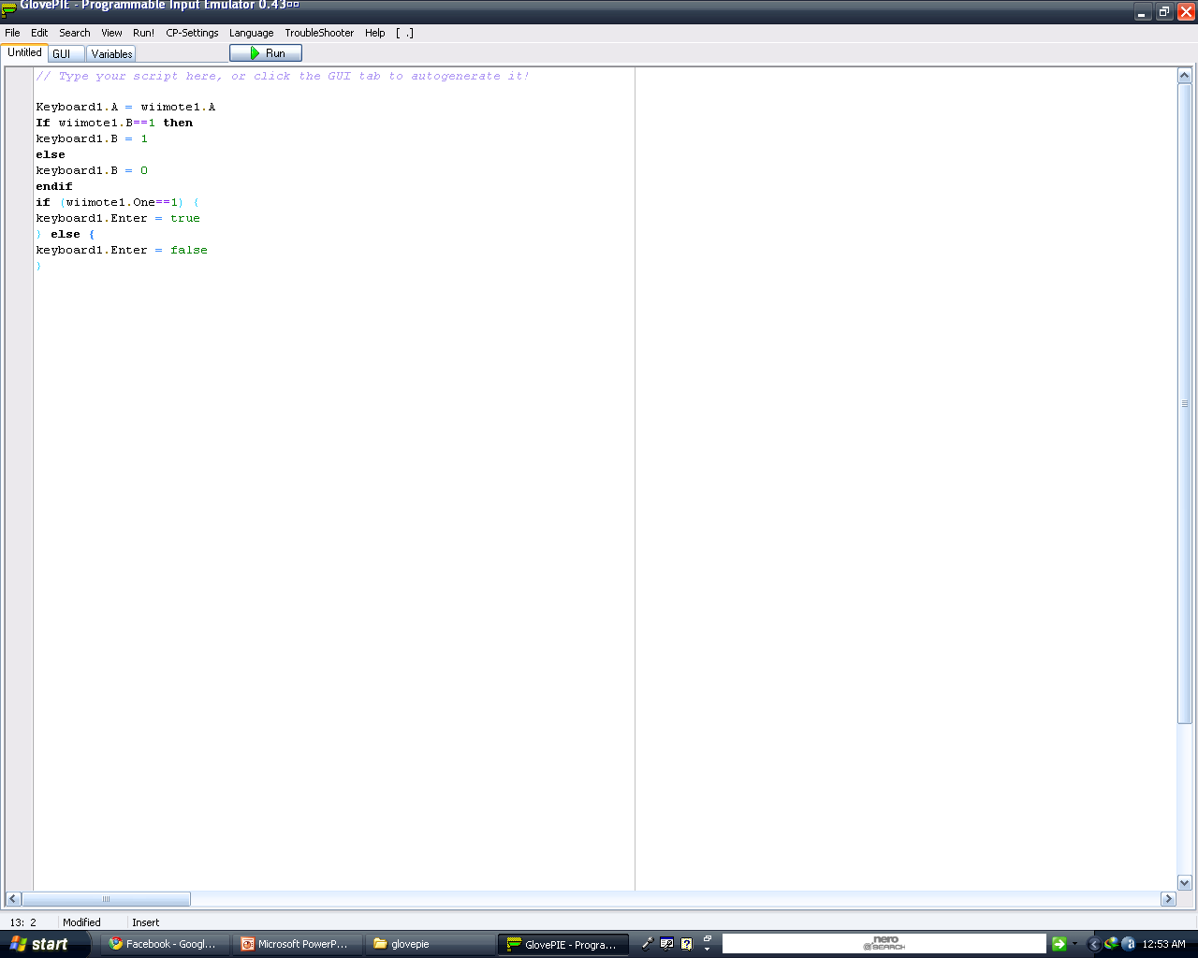

The picture shows the GlovePIE Programmer and a sample code of emulating keyboard keys via wiimote in different ways.

The GlovePIE uses a Linear but iterative execution method which means once the code has been executed from top to bottom, it will again start from top

2.BlueSoleil
BlueSoleil is a Bluetooth software/driver for Windows XP, Windows Vista, Windows 7, Linux, WinCE and Windows Mobile. It supports Bluetooth chipsets from CSR, Broadcom, Marvell etc. Bluetooth dongles, PCs, Laptops, PDAs, PNDs and UMPCs are sometimes bundled with a version of this software.
BlueSoleil is developed by IVT Corporation and the first version was released in 2002.
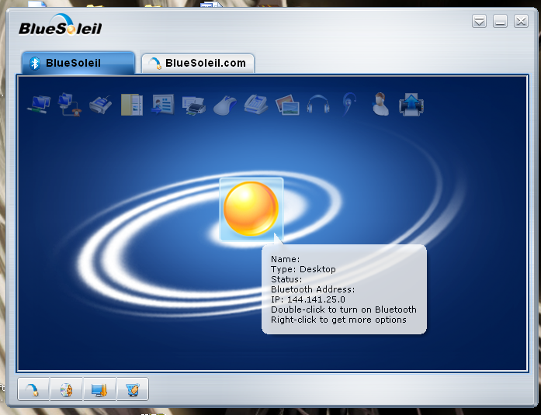

Demo software
A demonstration version of BlueSoleil is available, restricting the device after 2MB data transfer, approximately 1.5 minutes of high-quality audio or 2-4 hours of mouse use. The software must be purchased to enable unlimited use.

Features
BlueSoleil features the following technologies:
- Voice over IP
- Advanced Audio Distribution Profile and Audio/Video Remote Control Profile
- Personal Area Network
- Basic Imaging Profile
- Cordless Telephony Profile
- Instant Messaging
- Integration Phone tools as a profile

Interoperability
BlueSoleil has been distributed over 30 million copies. IVT has also established an interoperability testing centre where it has built up a large library of Bluetooth products which are on the market in order to perform interoperability testing.
Various Bluetooth dongles are delivered with an obsolete or demonstration version of Bluesoleil. New versions are available as a standalone purchase from the vendor's website. Regardless of whether the bundled or the standalone version is purchased, the software enforces licensing restrictions which tie it to the address of a specific Bluetooth dongle.
Bluesoleil works with the main Bluetooth Silicon Vendors hardware, such as Accelsemi, Atheros, CSR, Conwise, 3DSP, Broadcom, Intel, Marvell, NSC, RFMD, SiRF as well as baseband IP such as RivieraWaves BT IP.
If there is no Bluetooth dongle attached to the PC the Bluetooth logo will be grey, blue if a dongle is attached, and green when connected to another Bluetooth enabled device.

3.Wiimote Whiteboard
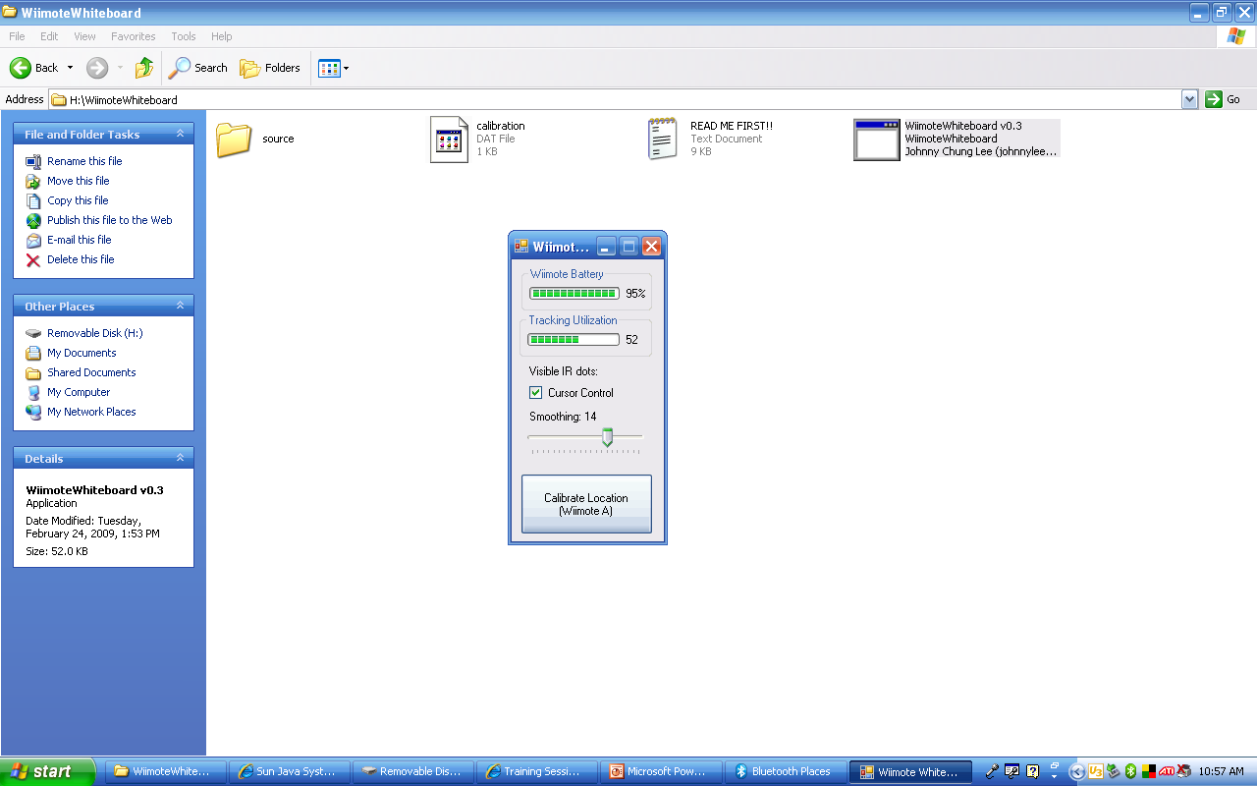
Since the Wiimote can track sources of infrared (IR) light, you can track pens that have an IR led in the tip. By pointing a wiimote at a projection screen or LCD display, you can create very low-cost interactive whiteboards or tablet displays. Since the Wiimote can track upto 4 points, up to 4 pens can be used. It also works great with rear-projected displays.
Software
The calibration and mouse cursor emulation software is available for you to download and try yourself. Note: My mouse emulation code isn't perfect. If any of you are programmers and can get it working with Alias Sketchbook, drop me a line.
1. Connect your wiimote to your PC via Bluetooth. There are a number of tutorials online on how to do this, possibly even for you specific software/hardware configuration. The Wiimote works with many (but not all) Bluetooth drivers. You can report/read about compatibility issues at WiimoteProject.com
2. Download the Wiimote Whiteboard software to the right. Please read the "READ ME.txt" file first! Make sure your wiimote is connected via Bluetooth, and then run the ".exe" in the main folder. NOTE: Good placement of the wiimote is key to good tracking. View the README for more info.
Multitouch: The multitouch demos are custom C# DirectX programs. You may download the sample program to the right, but this is provided for developers without support or documentation. The code is built on top of this Wiimote library. Unfortunately, multi-touch capable applications are currently extremely rare. Hopefully, that will change as more developers explore its potential.

4.Visual Basic
Visual Basic (VB) is the third-generation event-driven programming language and integrated development environment (IDE) fromMicrosoft for its COM programming model. Visual Basic is relatively easy to learn and use.[1][2]
Visual Basic was derived from BASIC and enables the rapid application development (RAD) of graphical user interface (GUI) applications, access to databases using Data Access Objects, Remote Data Objects, or ActiveX Data Objects, and creation of ActiveX controls and objects. Scripting languages such as VBA and VBScript are syntactically similar to Visual Basic, but perform differently.
A programmer can put together an application using the components provided with Visual Basic itself. Programs written in Visual Basic can also use the Windows API, but doing so requires external function declarations.
The final release was version 6 in 1998. Microsoft's extended support ended in March 2008 and the designated successor was Visual Basic .NET (now known simply as Visual Basic).

Language features
Like the BASIC programming language, Visual Basic was designed to be easily learned and used by beginner programmers. The language not only allows programmers to create simpleGUI applications, but can also develop complex applications. Programming in VB is a combination of visually arranging components or controls on a form, specifying attributes and actions of those components, and writing additional lines of code for more functionality. Since default attributes and actions are defined for the components, a simple program can be created without the programmer having to write many lines of code. Performance problems were experienced by earlier versions, but with faster computers and native code compilation this has become less of an issue.
Although programs can be compiled into native code executables from version 5 onwards, they still require the presence of runtime libraries of approximately 1 MB in size. This runtime is included by default in Windows 2000 and later, but for earlier versions of Windows like 95/98/NT it must be distributed together with the executable.
Forms are created using drag-and-drop techniques. A tool is used to place controls (e.g., text boxes, buttons, etc.) on the form (window). Controls have attributes and event handlersassociated with them. Default values are provided when the control is created, but may be changed by the programmer. Many attribute values can be modified during run time based on user actions or changes in the environment, providing a dynamic application. For example, code can be inserted into the form resize event handler to reposition a control so that it remains centered on the form, expands to fill up the form, etc. By inserting code into the event handler for a keypress in a text box, the program can automatically translate the case of the text being entered, or even prevent certain characters from being inserted.
Visual Basic can create executables (EXE files), ActiveX controls, or DLL files, but is primarily used to develop Windows applications and to interface database systems. Dialog boxes with less functionality can be used to provide pop-up capabilities. Controls provide the basic functionality of the application, while programmers can insert additional logic within the appropriate event handlers. For example, a drop-down combination box will automatically display its list and allow the user to select any element. An event handler is called when an item is selected, which can then execute additional code created by the programmer to perform some action based on which element was selected, such as populating a related list.
Alternatively, a Visual Basic component can have no user interface, and instead provide ActiveX objects to other programs via Component Object Model (COM). This allows for server-sideprocessing or an add-in module.
The language is garbage collected using reference counting, has a large library of utility objects, and has basic object oriented support. Since the more common components are included in the default project template, the programmer seldom needs to specify additional libraries. Unlike many other programming languages, Visual Basic is generally not case sensitive, although it will transform keywords into a standard case configuration and force the case of variable names to conform to the case of the entry within the symbol table. String comparisons are case sensitive by default, but can be made case insensitive if so desired.
The Visual Basic compiler is shared with other Visual Studio languages (C, C++), but restrictions in the IDE do not allow the creation of some targets (Windows model DLLs) and threading models.

History
VB 1.0 was introduced in 1991. The drag and drop design for creating the user interface is derived from a prototype form generator developed by Alan Cooper and his company calledTripod. Microsoft contracted with Cooper and his associates to develop Tripod into a programmable form system for Windows 3.0, under the code name Ruby (no relation to the Ruby programming language).
Tripod did not include a programming language at all. Microsoft decided to combine Ruby with the Basic language to create Visual Basic.
The Ruby interface generator provided the "visual" part of Visual Basic and this was combined with the "EB" Embedded BASIC engine designed for Microsoft's abandoned "Omega" database system. Ruby also provided the ability to load dynamic link libraries containing additional controls (then called "gizmos"), which later became the VBX interface.[7]

Timeline
- Project 'Thunder' was initiated
- Visual Basic 1.0 (May 1991) was released for Windows at the Comdex/Windows World trade show in Atlanta, Georgia.
- Visual Basic 1.0 for DOS was released in September 1992. The language itself was not quite compatible with Visual Basic for Windows, as it was actually the next version of Microsoft's DOS-based BASIC compilers, QuickBASIC and BASIC Professional Development System. The interface used a Text user interface, using extended ASCII characters to simulate the appearance of a GUI.
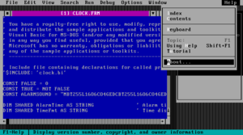

Visual Basic for MS-DOS
- Visual Basic 2.0 was released in November 1992. The programming environment was easier to use, and its speed was improved. Notably, forms became instantiable objects, thus laying the foundational concepts of class modules as were later offered in VB4.
- Visual Basic 3.0 was released in the summer of 1993 and came in Standard and Professional versions. VB3 included version 1.1 of the Microsoft Jet Database Engine that could read and write Jet (or Access) 1.x databases.
- Visual Basic 4.0 (August 1995) was the first version that could create 32-bit as well as 16-bit Windows programs. It also introduced the ability to write non-GUI classes in Visual Basic. Incompatibilities between different releases of VB4 caused installation and operation problems. While previous versions of Visual Basic had used VBX controls, Visual Basic now used OLE controls (with files names ending in .OCX) instead. These were later to be named ActiveX controls.
- With version 5.0 (February 1997), Microsoft released Visual Basic exclusively for 32-bit versions of Windows. Programmers who preferred to write 16-bit programs were able to import programs written in Visual Basic 4.0 to Visual Basic 5.0, and Visual Basic 5.0 programs can easily be converted with Visual Basic 4.0. Visual Basic 5.0 also introduced the ability to create custom user controls, as well as the ability to compile to native Windows executable code, speeding up calculation-intensive code execution. A free, downloadable Control Creation Edition was also released for creation of ActiveX controls. It was also used as an introductory form of Visual Basic: a regular .exe project could be created and run in the IDE, but not compiled.
- Visual Basic 6.0 (Mid 1998) improved in a number of areas [8] including the ability to create web-based applications. VB6 has entered Microsoft's "non-supported phase" as of March2008. Although the Visual Basic 6.0 development environment is no longer supported, the runtime is supported on Windows Vista, Windows Server 2008 and Windows 7.
- Mainstream Support for Microsoft Visual Basic 6.0 ended on March 31, 2005. Extended support ended in March 2008. In response, the Visual Basic user community expressed its grave concern and lobbied users to sign a petition to keep the product alive. Microsoft has so far refused to change their position on the matter. Ironically, around this time (2005), it was exposed that Microsoft's new anti-spyware offering, Microsoft AntiSpyware (part of the GIANT Company Software purchase), was coded in Visual Basic 6.0. Its replacement, Windows Defender, was rewritten as C++ code.

PROJECT FORMS AND CODING

Login Screen
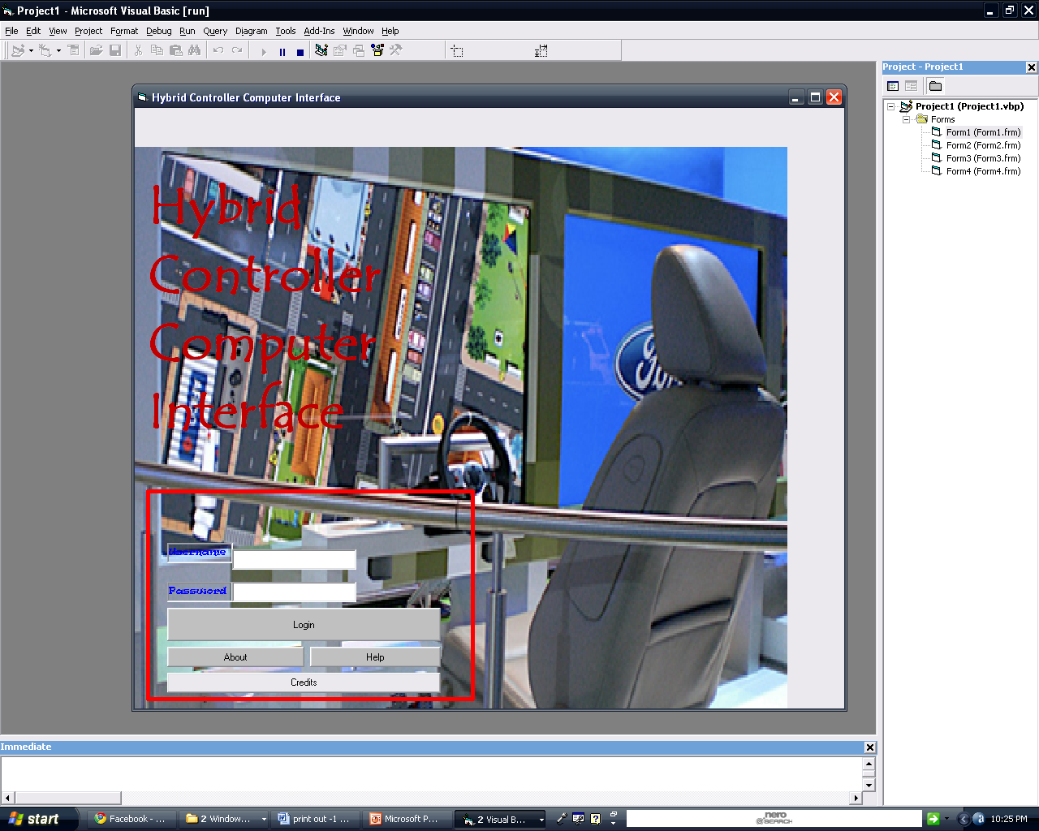
Private Sub Command1_Click()
If Text1.Text = user & Text2.Text = abc Then
Text1.Text = ""
Text2.Text = ""
Form1.Hide
Form3.Show
Else
MsgBox "incorrect username and password combination, try again :-)", 1, "login failed"
End If
End Sub

Private Sub Command2_Click()
MsgBox "This project provides and intuitive, unique and new interface" & vbCrLf & "to your pc.It Includes controlling you pc by" & vbCrLf & "1.Your Touch" & vbCrLf & "2. Finger Tracking" & vbCrLf & "3.Voice Commands" & vbCrLf & "4.Motion Controls via additional controller" & vbCrLf & "We Hope you enjoy Our Project....Have FUN!! :-0 :-) :-P", 0, "About"
End Sub

Private Sub Command3_Click()
MsgBox "make sure you have obtained a username and password" & vbCrLf & "for yourself before logging in", vbOKOnly, "help"
End Sub

Private Sub Command4_Click()
MsgBox "Vikas Singh" & vbCrLf & "Parag Rajhans" & vbCrLf & "Aditya Athalye" & vbCrLf & "Akshay Baviskar" & vbCrLf & "Viraj Deshmukh", 0, "Credits"
End Sub
Main Interface
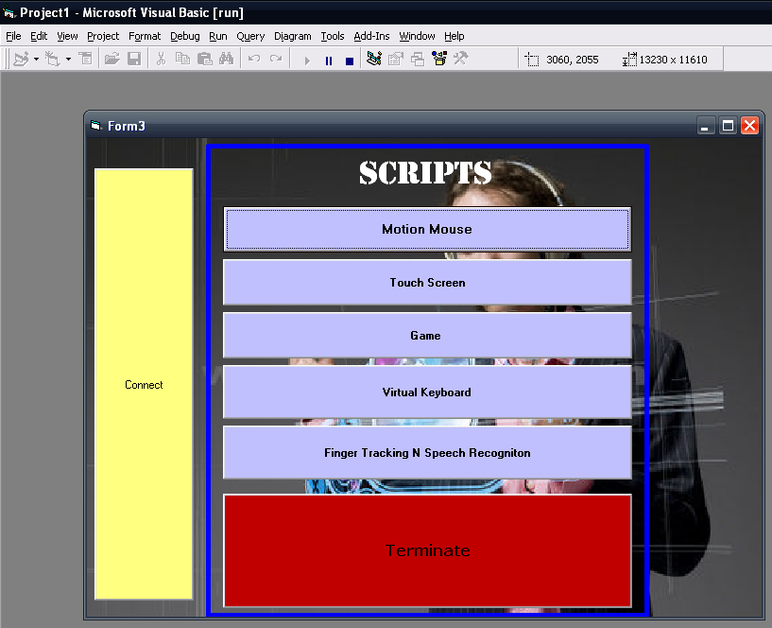
Private Declare Function ShellExecute Lib "shell32.dll" Alias "ShellExecuteA" _
(ByVal hwnd As Long, ByVal lpOperation As String, _
ByVal lpFile As String, ByVal lpParameters As String, _
ByVal lpDirectory As String, ByVal nShowCmd As Long) As Long

Private Sub Command1_Click()
Dim ret As Long
ret = ShellExecute(Me.hwnd, vbNullString, "mymouse.PIE", vbNullString, "C:\Documents and Settings\Vikas Team V.A.S.T\Desktop\glovepie\Myscripts\", 1)
Timer1.Enabled = True
End Sub

Private Sub Command2_Click()
Shell "taskkill /F /IM GlovePIE.exe"
Shell "taskkill /F /IM WiimoteWhiteboard v0.3.exe"
End Sub
Private Sub Command3_Click()
Dim ret As Long
ret = ShellExecute(Me.hwnd, vbNullString, "WiimoteWhiteboard v0.3.exe", vbNullString, "C:\HCCI\Installs\WiimoteWhiteboard\", 1)
Timer4.Enabled = True
End Sub

Private Sub Command4_Click()
Dim ret As Long
ret = ShellExecute(Me.hwnd, vbNullString, "game.PIE", vbNullString, "C:\Documents and Settings\Vikas Team V.A.S.T\Desktop\glovepie\Myscripts\", 1)
Timer2.Enabled = True
End Sub

Private Sub Command5_Click()
Dim ret As Long
ret = ShellExecute(Me.hwnd, vbNullString, "BlueSoleil.exe", vbNullString, "C:\Program Files\IVT Corporation\BlueSoleil\", 1)
End Sub

Private Sub Command6_Click()
Form4.Show
End Sub

Private Sub Command7_Click()
Dim ret As Long
ret = ShellExecute(Me.hwnd, vbNullString, "finalfinger.PIE", vbNullString, "C:\Documents and Settings\Vikas Team V.A.S.T\Desktop\glovepie\Myscripts\", 1)
Timer1.Enabled = True
End Sub

Private Sub Timer1_Timer()
Timer1.Enabled = False
SendKeys "{F9}"
End Sub

Private Sub Timer2_Timer()
Timer2.Enabled = False
SendKeys "{F9}"
Timer3.Enabled = True
End Sub

Private Sub Timer3_Timer()
Timer3.Enabled = False
Dim ret As Long
ret = ShellExecute(Me.hwnd, vbNullString, "Nuclear_Motocross.swf", vbNullString, "C:\Documents and Settings\Vikas Team V.A.S.T\Desktop\proj forms\Finals\", 1)
End Sub
Private Sub Timer4_Timer()
Timer4.Enabled = False
SendKeys "{TAB}"
SendKeys " "
End Sub

SCRIPTS(In GlovePIE Programmer)
1.MOTION MOUSE
debug = wiimote1.rawacc
if wiimote1.B && wiimote1.Minus then
if var.x=1 then
hidepie()
var.x=var.x*-1
else
showpie()
var.x=var.x*-1
endif
endif
//showpie() = wiimote1.B + wiimote1.Minus
//hidepie()
//mouse buttons
mouse.LeftButton = wiimote1.A

mouse.RightButton = wiimote1.B
mouse.MiddleButton = wiimote1.home
mouse.WheelUp = wiimote1.Plus
mouse.WheelDown = wiimote1.Minus
//keyboard buttons in mouse
keyboard.Alt+keyboard.F4 = wiimote1.left+wiimote1.SwingUp
keyboard.Up = wiimote1.Up
keyboard.Down = wiimote1.Down
keyboard.Left = wiimote1.Left
keyboard.Right = wiimote1.Right
keyboard.Enter = wiimote1.Two
//MOUSE CURSOR
//controlling x axis
//positive x
if wiimote1.rawaccx>1 and wiimote1.RawAccX<3 then
mouse1.x = mouse.x - 0.002
endif
if wiimote1.RawAccX>=3 &&wiimote1.RawAccX<7 then
mouse1.x = mouse.x - 0.004
endif
if wiimote1.RawAccX>=7 && wiimote1.RawAccX<=10 then
mouse1.x = mouse.x-0.006
endif
//negative x
if wiimote1.RawAccX<-1&&wiimote.RawAccX>-3 then
mouse1.x = mouse.x + 0.002
endif
if wiimote1.RawAccX<=-3 &&wiimote1.RawAccX>-7 then
mouse1.x = mouse.x + 0.004
endif
if wiimote1.RawAccX<=-7 && wiimote1.RawAccX>=-10 then
mouse1.x = mouse.x +0.006
endif
//controlling y axis
//positive y
if wiimote1.RawAccz>1&&wiimote.RawAccz<3 then
mouse1.y = mouse.y - 0.002
endif
if wiimote1.RawAccz>3 && wiimote1.RawAccz<7 then
mouse1.y = mouse.y - 0.004
endif
if wiimote1.RawAccz>7 && wiimote1.RawAccz<10 then
mouse1.y = mouse.y-0.006
endif
//negative y
if wiimote1.RawAccz<-1&&wiimote.RawAccz>-3 then
mouse1.y = mouse.y + 0.002
endif
if wiimote1.RawAccz<=-3 && wiimote1.RawAccz>-7 then
mouse1.y = mouse.y + 0.004
endif
if wiimote1.RawAccz<=-7 && wiimote1.RawAccz>=-10 then
mouse1.y = mouse.y + 0.006
endif
2.TouchScreen



2.1 Virtual Keyboard
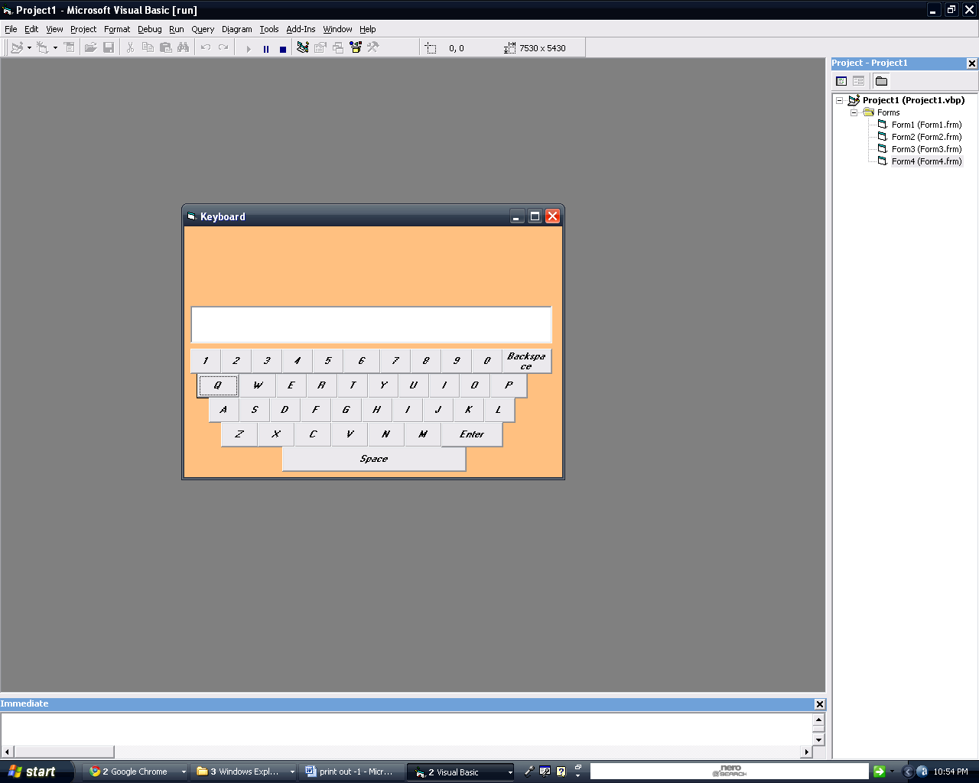
Private Sub Command1_Click()
Text1.SetFocus
SendKeys ("q")
End Sub

Private Sub Command10_Click()
Text1.SetFocus
SendKeys ("p")
End Sub

Private Sub Command11_Click()
Text1.SetFocus
SendKeys ("a")
End Sub

Private Sub Command12_Click()
Text1.SetFocus
SendKeys ("S")
End Sub

Private Sub Command13_Click()
Text1.SetFocus
SendKeys ("d")
End Sub

Private Sub Command14_Click()
Text1.SetFocus
SendKeys ("f")
End Sub

Private Sub Command15_Click()
Text1.SetFocus
SendKeys ("g")
End Sub

Private Sub Command16_Click()
Text1.SetFocus
SendKeys ("h")
End Sub

Private Sub Command17_Click()
Text1.SetFocus
SendKeys ("i")
End Sub

Private Sub Command18_Click()
Text1.SetFocus
SendKeys ("j")
End Sub

Private Sub Command19_Click()
Text1.SetFocus
SendKeys ("k")
End Sub

Private Sub Command2_Click()
Text1.SetFocus
SendKeys ("w")
End Sub

Private Sub Command20_Click()
Text1.SetFocus
SendKeys ("l")
End Sub

Private Sub Command21_Click()
Text1.SetFocus
SendKeys ("z")
End Sub

Private Sub Command22_Click()
Text1.SetFocus
SendKeys ("x")
End Sub

Private Sub Command23_Click()
Text1.SetFocus
SendKeys ("c")
End Sub

Private Sub Command24_Click()
Text1.SetFocus
SendKeys ("v")
End Sub

Private Sub Command25_Click()
Text1.SetFocus
SendKeys ("n")
End Sub

Private Sub Command26_Click()
Text1.SetFocus
SendKeys ("m")
End Sub

Private Sub Command27_Click()
Text1.SetFocus
SendKeys ("1")
End Sub

Private Sub Command28_Click()
Text1.SetFocus
SendKeys ("2")
End Sub

Private Sub Command29_Click()
Text1.SetFocus
SendKeys ("3")
End Sub

Private Sub Command3_Click()
Text1.SetFocus
SendKeys ("e")
End Sub

Private Sub Command30_Click()
Text1.SetFocus
SendKeys ("4")
End Sub

Private Sub Command31_Click()
Text1.SetFocus
SendKeys ("5")
End Sub

Private Sub Command32_Click()
Text1.SetFocus
SendKeys ("6")
End Sub

Private Sub Command33_Click()
Text1.SetFocus
SendKeys ("7")
End Sub

Private Sub Command34_Click()
Text1.SetFocus
SendKeys ("8")
End Sub

Private Sub Command35_Click()
Text1.SetFocus
SendKeys ("9")
End Sub

Private Sub Command36_Click()
Text1.SetFocus
SendKeys ("0")
End Sub

Private Sub Command37_Click()
Text1.SetFocus
SendKeys ("{BKSP}")
End Sub

Private Sub Command38_Click()
Text1.SetFocus
SendKeys (" ")
End Sub

Private Sub Command39_Click()
Text1.SetFocus
SendKeys ("{ENTER}")
End Sub

Private Sub Command4_Click()
Text1.SetFocus
SendKeys ("r")
End Sub

Private Sub Command5_Click()
Text1.SetFocus
SendKeys ("t")
End Sub

Private Sub Command6_Click()
Text1.SetFocus
SendKeys ("y")
End Sub

Private Sub Command7_Click()
Text1.SetFocus
SendKeys ("u")
End Sub

Private Sub Command8_Click()
Text1.SetFocus
SendKeys ("i")
End Sub

Private Sub Command9_Click()
Text1.SetFocus
SendKeys ("o")
End Sub

Private Sub Form_Load()
Dim caps As Integer
caps = 1
End Sub

3. Finger Tracking and Speech Recognition
debug = "w1: "+wiimote1.dot1intensity +" w2:" +wiimote2.dot2intensity
Mouse.CursorPosX = smooth(Screen.Width - ((wiimote.dot1x * Screen.Width) / 1016 ))
Mouse.CursorPosY = smooth(Screen.Height - ((wiimote.dot1y * Screen.Height )/ 760))
mouse1.LeftButton = wiimote1.dot2vis

if said("switch",5) then
keyboard1.Alt+keyboard1.Tab = true
keyboard1.Tab = false
endif
if said("maximise",5) then
keyboard1.Alt = false
keyboard1.Tab = false
endif
if said("close",5) then
keyboard.Alt+keyboard.F4 = true
keyboard.Alt+keyboard.F4 = false
endif
if said("minimize",5) then
keyboard1.Alt = true
keyboard1.Space = true
keyboard.N = true
keyboard1.alt= false
keyboard1.Space = false
keyboard1.N = false
endif
if said("minimize all",5) then
keyboard1.Windows+keyboard.M = true
keyboard1.Windows+keyboard.M = false
endif

Future scope

- With further improvements on the controllers or the hardware of Bluetooth, we can control out pc without any additional gloves or add-ons ..
- That is we can simply use our body movements to control the s/w
- This would also include making various facial expressions for various functions
- Like we can tilt our head to rotate a picture onscreen and blink our eyes to capture the screen
- Also, currently in beta stages, we can use brain signal mapping for various function like we can think of sentences in our mind, and the brain waves will be mapped to type those sentences

Applications

- Using Capabilities of Wiimote And Nunchuk (IR Tracking, Motion Capture, Gesture recognition and Buttons!!) we can control the pc
- Example: If My Wiimote and Nunchuk are swung upwards.. can write a program to detect upwards motion and perform a window close operation on my pc
- Similarly we can write a program to track an infrared source of light (by wiimote’s inbuilt infrared camera tracking by spatial triangulation) to control a mouse on screen.
- Thus my combining such programs we can create a virtual interface in which we just move our hands, make motion gestures, touch the screen or speak to interface with the computer.

References

- www.wikipedia.com
- www.wiibrew.org
- www.glovepie.org
- www.msdn.com
- www.codeguru.com

